Installing Hyper-V on windows 2012 R2 Server

***** If installing in VMware workstation …. Edit the vmx file in the 2012 virtual machine folder and add following lines in it.

hypervisor.cpuid.v0 = "FALSE"
mce.enable = “True”
vhu.enable = “True”

After installing Windows server 2012 R2 open server manager. It is the icon next to start button.

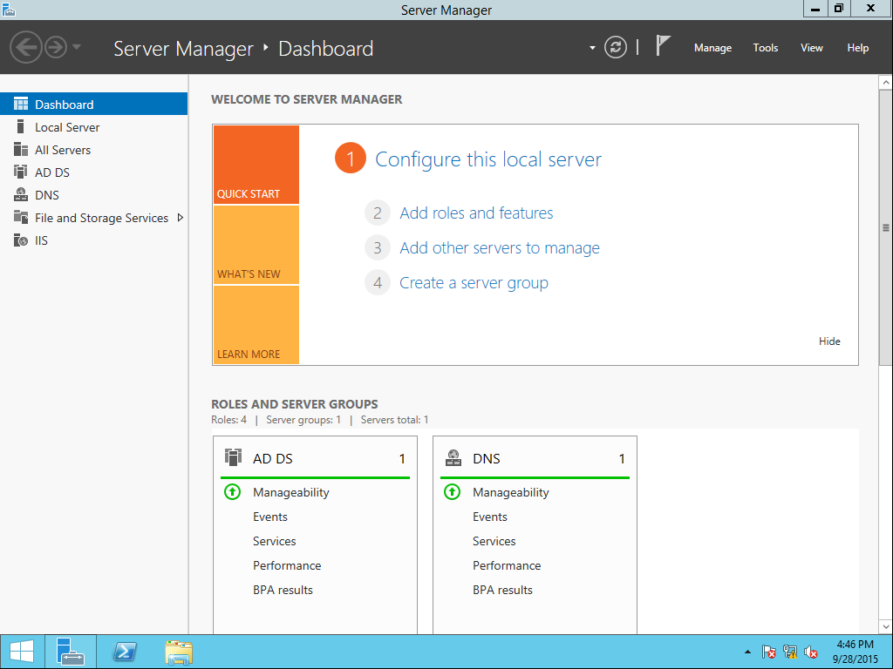

Click manage and select Add roles and features.

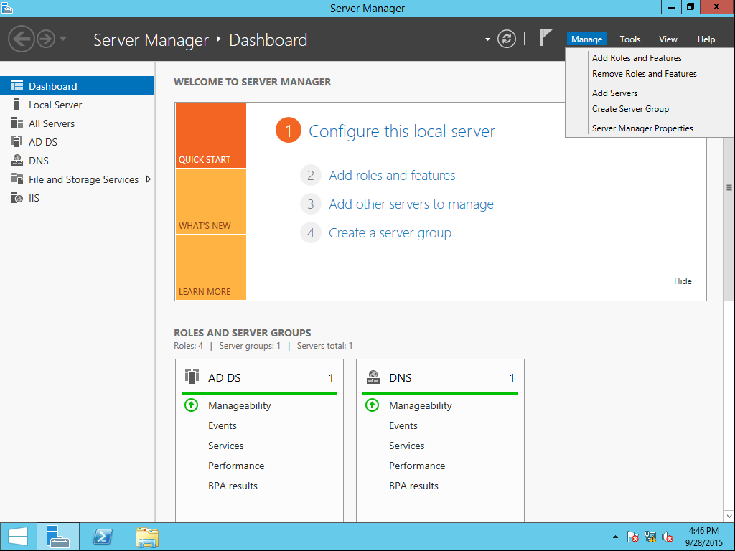
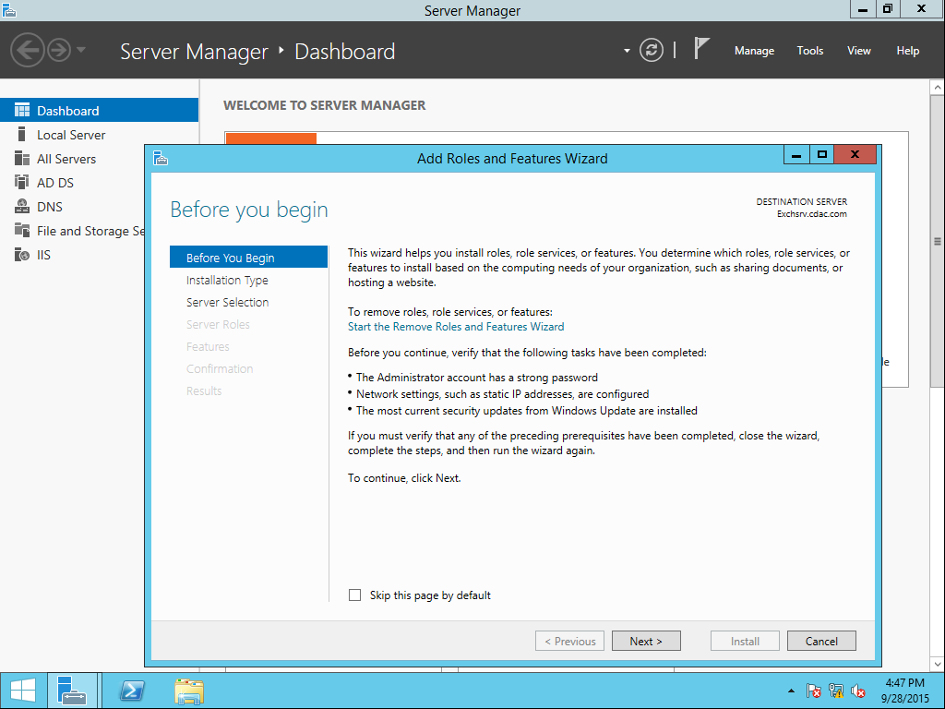

Click Next
On the next screen make sure Role based or feature based installation is selected and click Next.
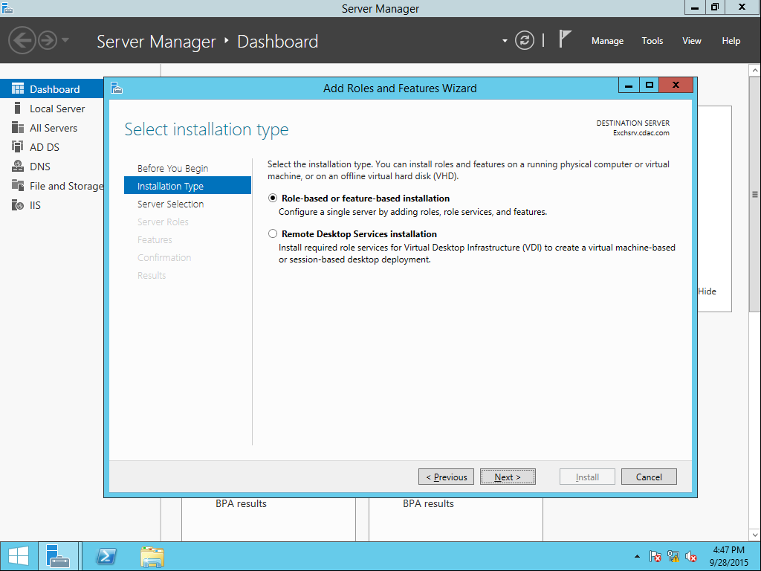

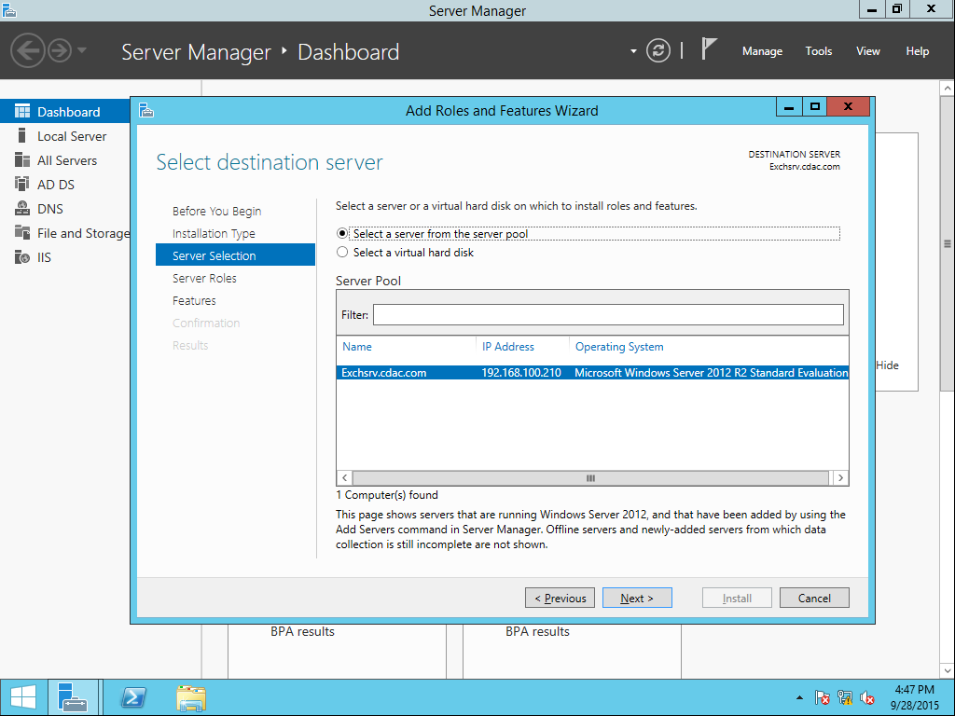

Click Next on the above screen. On the following screen select the Hyper-V role check box.

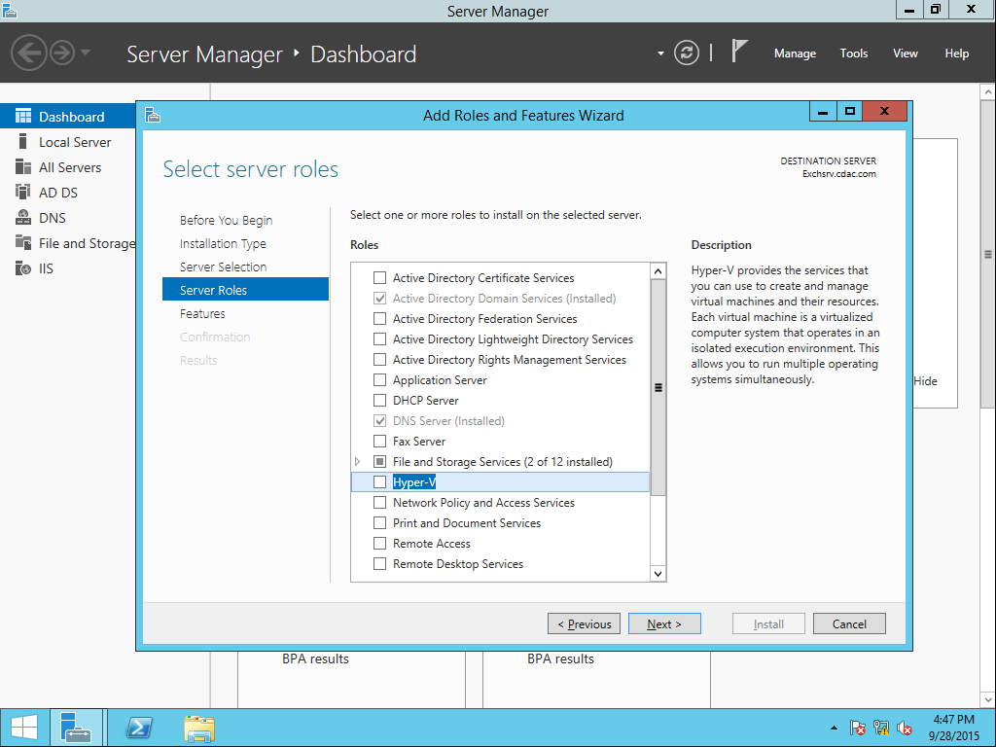

Click Add Features on the following window.

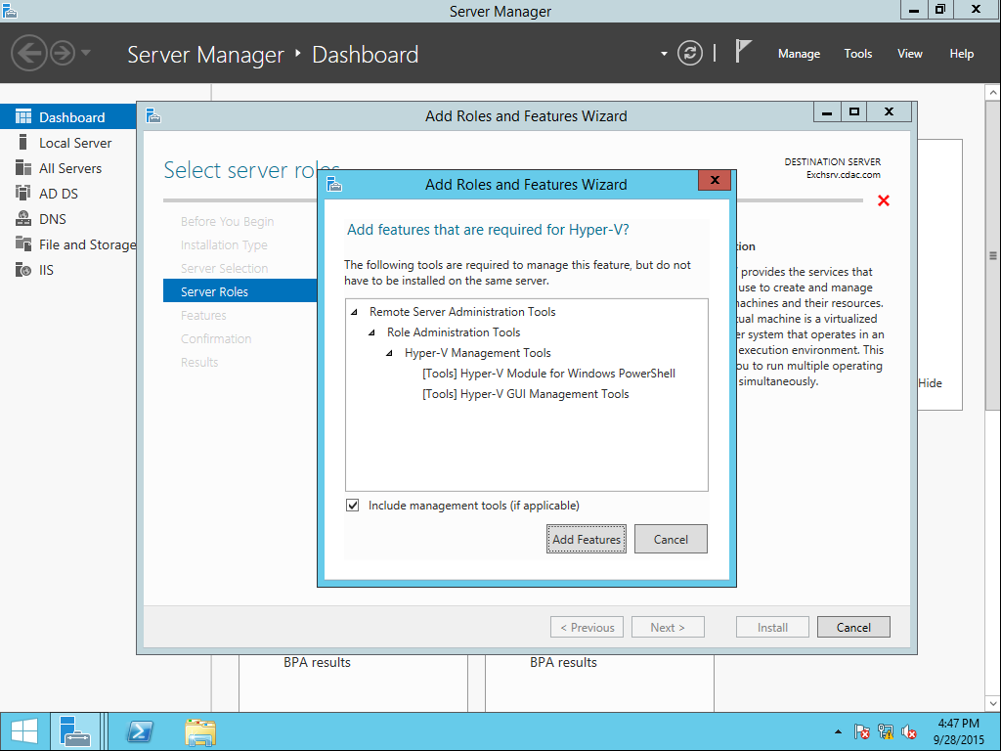

Click Next on the below window without selecting anything.

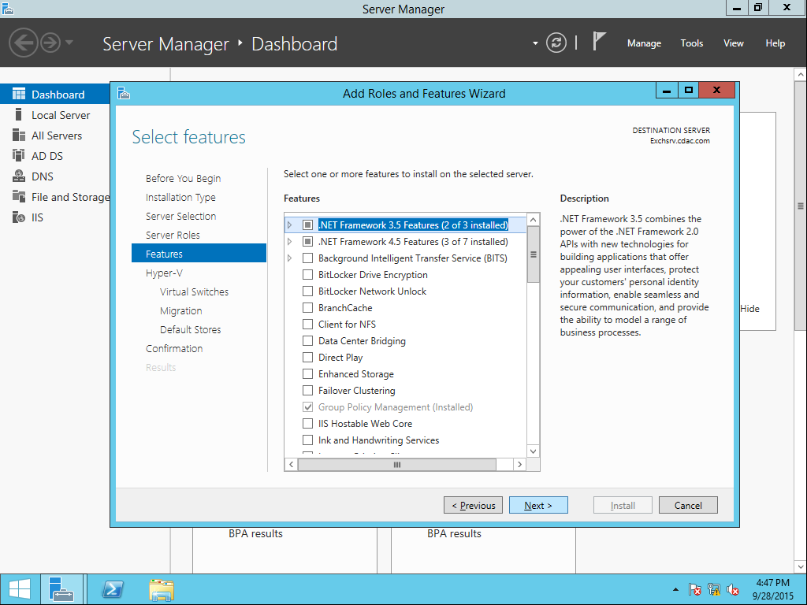

Click Next on the following screen.

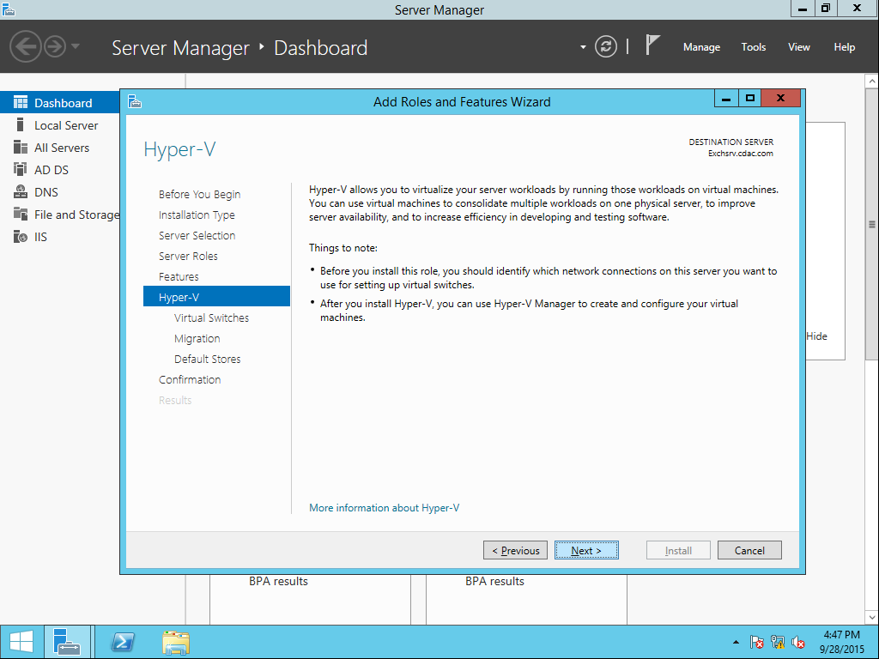

On the following screen select the check box to create a network.

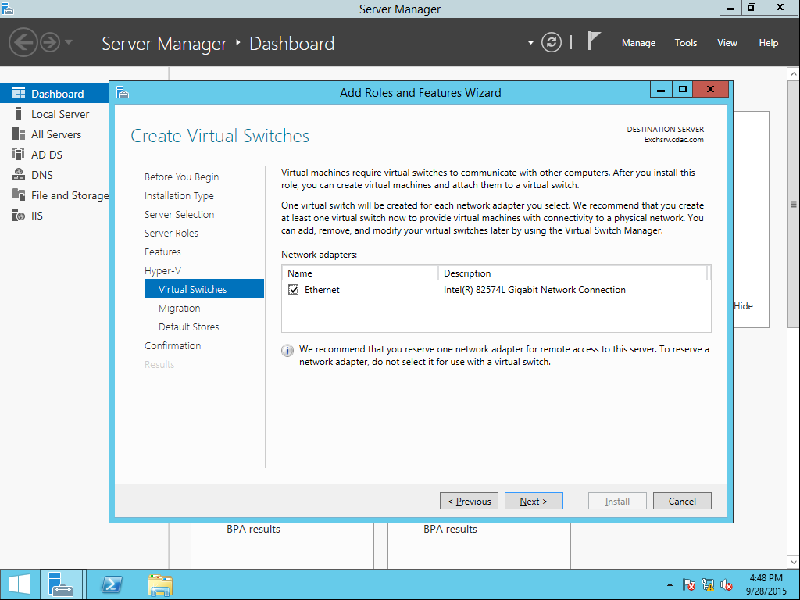

Click Next on the following screen.
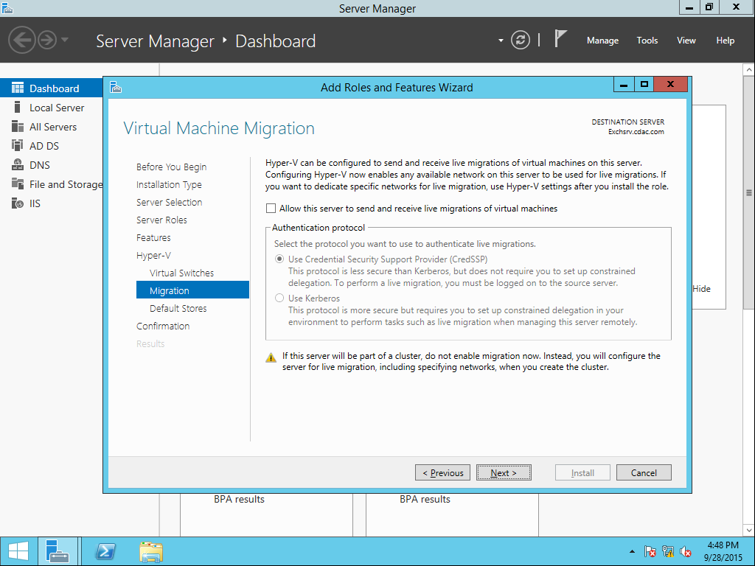

Click next to select the default values.

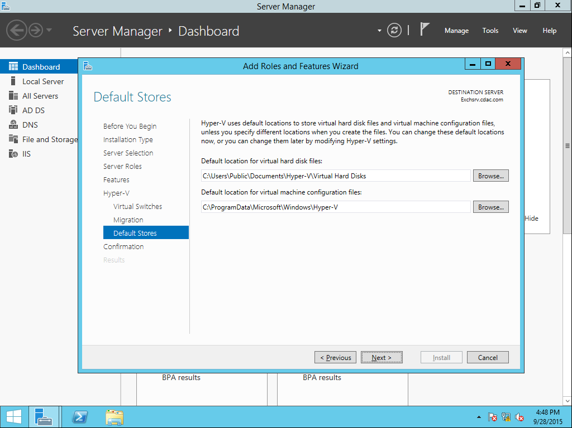

Click Install on the following screen to install Hyper-V role.

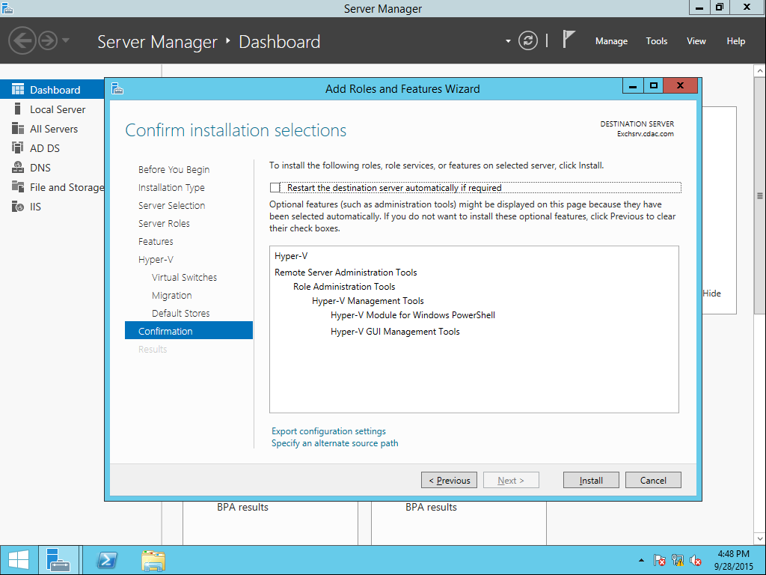

It will take time to install. Once installation is finished, click close on the following screen.

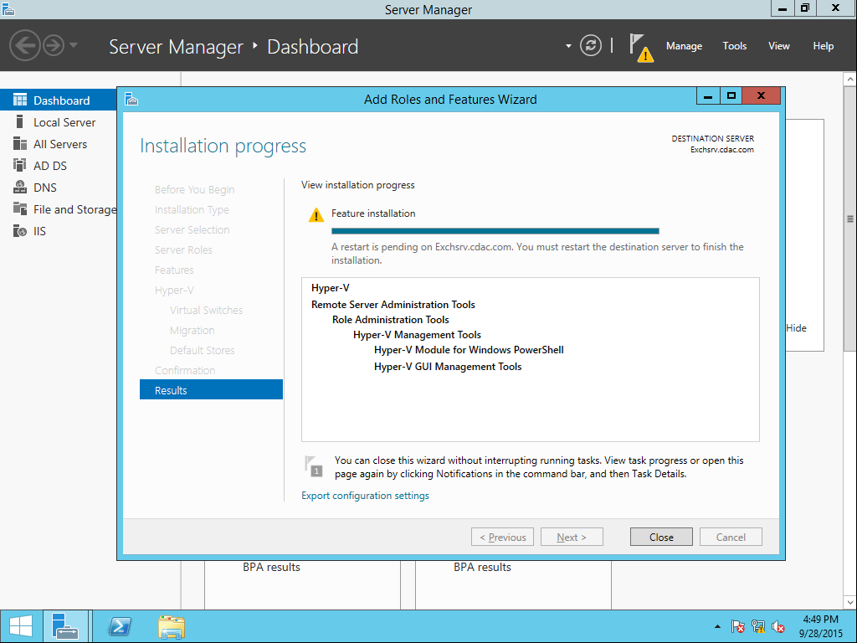
Restart the system.

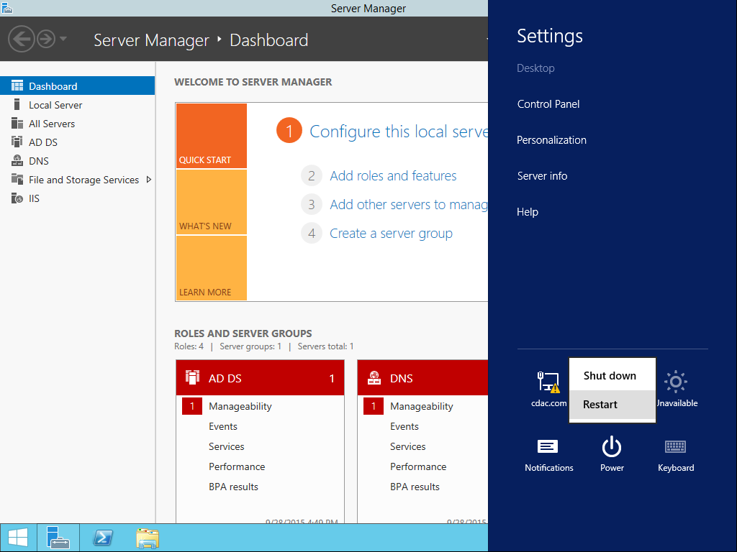

Once the system restarts log in as administrator. Start Server manager. Click tools and select hyper-v manager.

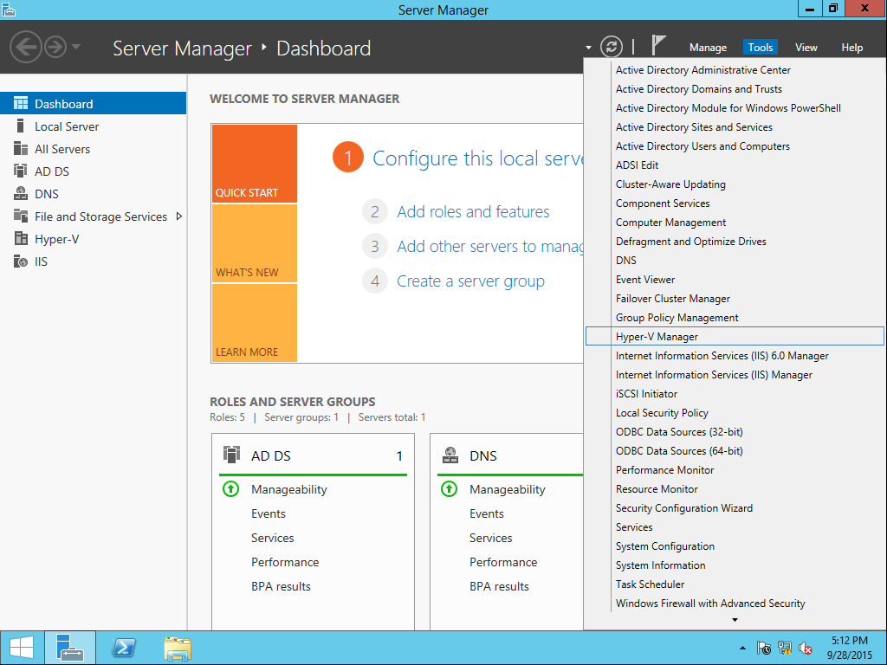

Once the Hyper-v manager opens, double click Hyper-V manager to expand. The server name is displayed. Right click on it and create a new virtual machine by selecting New option.
